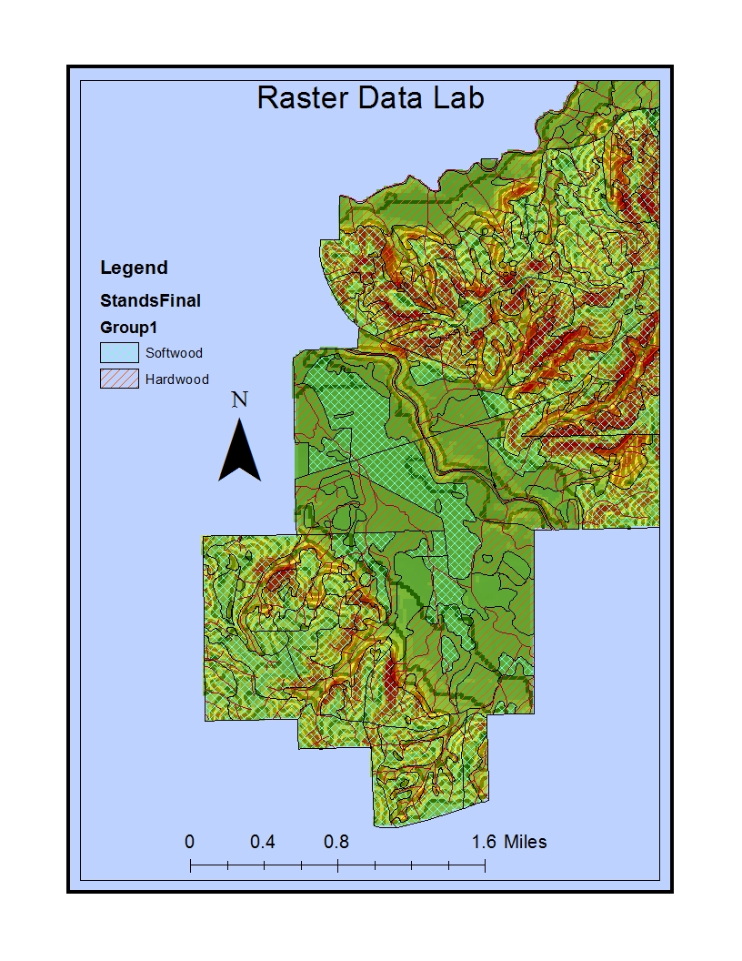
The streams did seem to match the relief, the layout is simple to follow with the crosshatches with the different color, although I may have needed a darker one to differentiate the bright colors better for hardwood and softwood. The conclusions that could be drawn is the best place to harvest and possibly which types of wood grow better where.

